**Department of Computer Science & Engineering**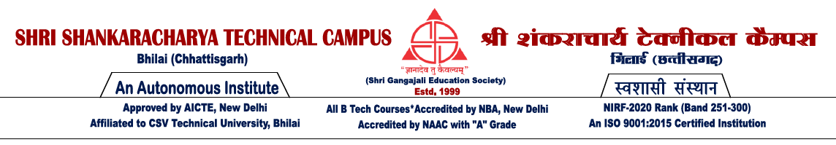

**MAJOR PROJECT-I SYNOPSIS**

**Semester:7th (Session :- Nov-Dec 2024)**

**Name:- Anurag Kumar , Masoom Yadav, Ashutosh Raja**

**Roll No:- 301410921040, 301410921075, 301410921070**

**Project Title :- Sign Language Detection Using Hand Gesture Recognition with OpenCV and Python.**

**Synopsis of Project :**-

**The aim of this project is to design and develop a real-time Sign Language Detector using computer vision techniques, particularly hand gesture recognition. The system leverages OpenCV for image processing and python-based machine learning frameworks, to recognize hand gestures and translate them into readable text. MediaPipe is used to efficiently track hand movements, making the system capable of recognizing various gestures in real-time.**

**Hardware/ Software Requirements :-**

**Hardware Requirements :- Software Requirements :-**

**Processor :- i5 or higher Frontend: -Not applicable**

**Ram :- 8GB or higher Backend :- Python**

**Storage :- Atleast 256Gb SSD Libraries: OpenCV, TensorFlow**

**Camera: Webcam of choice.**

**Application of Project :-**

**Assisting individuals with hearing or speech impairments to communicate more easily through recognized hand gestures.**

**Future work (Scope of work) :-**

**Integrating Augmented Reality (AR) technology can create a more immersive experience.**

**Name of the Guide :- Signature**

**Name of the Coordinator :- Signature**

**HOD**

**Dept. of CSE**